Commercial Thinning Survey Methodology -2021-2022

Objectives of Post-Commercial Thinning Field Monitoring
- To collect attributes for the calculation of tree and stand volumes.
- To collect site index information.
- To assess and collect tree attributes for:
- future growth and yield assessment,
- post-harvest damage and forest health information.

Field Measurements
Tree measurements are discussed in this section as they appear on the field cards, but the field crew is free to measure attributes in the most efficient sequence.
- Establish plot layout and identify (spray) trees to measure.
- 10m x 20m rectangular fixed area plot (200m²). Plot location is in the centroid/middle of the plot. From plot centre; parallel to access trails extend 5 m in each direction, perpendicular to access trails extend 10 m in each direction. If the mechanical thinning guidance is followed, 25% plot area is occupied by the trail and should have no trees.
- Measure all trees in the plot, species, diameters, heights, vigour/quality class, Crown position, height to live crown.
- Record damage agent and severity codes.
- Assess and record wildlife use and slash loading (ie surveyor comments)
- Site index trees: record breast height age of at least one top height tree per strip line.
- Data entry into the excel spreadsheet.

Sampling Plan/Plot Location
- Maintain intensity of at least 0.4 plots/ha (2.5 ha/plot) if the size of the block may vary between 60 to 100 ha. (15 to 25 plots per block), minimum of 5 plots.
- For this contract the plot locations and replacements were pre-selected using the following methodology:
  - Overlay a grid over the block, with the y-axis oriented parallel to the access trails. Baselines (x-axis) perpendicular to the majority of the access trails
  - Measure the height (Y) and width (X) distances of the block
  - Strip lines/transect: The interval between transects Random number between 5 and y-5m, n=3 (rows or transect), the interval is (y-5y3=z) First line will be a uniform random number U between 5 and z+5, second row=u+z and third=u+2z
  - Plot centres: In ArcMap, points were placed along the line feature, at 30m intervals. The number of plots required for the block were distributed evenly between the 3 strip lines. A random number generator was used to select the required number of plots on the strip. The geographic coordinates were generated in the spatial layer.

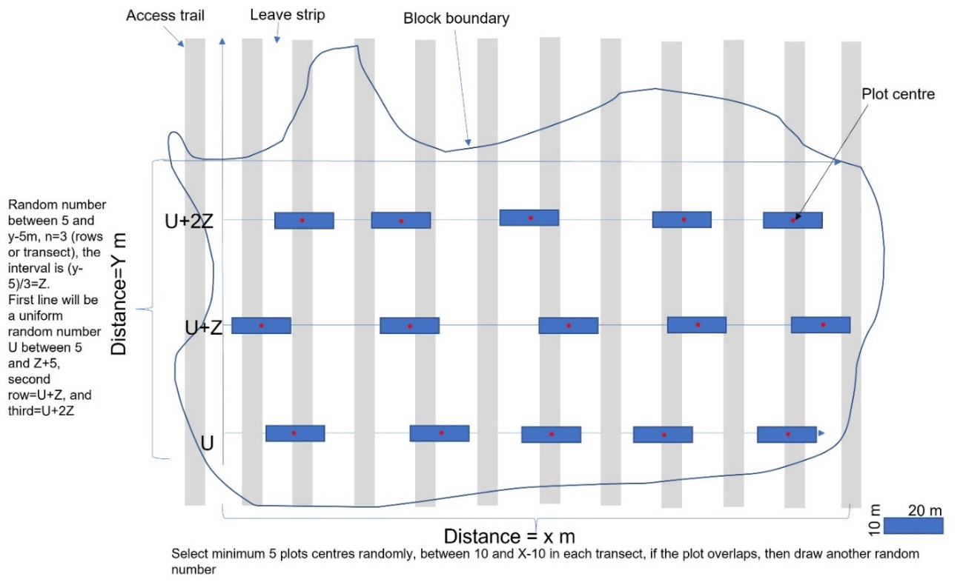
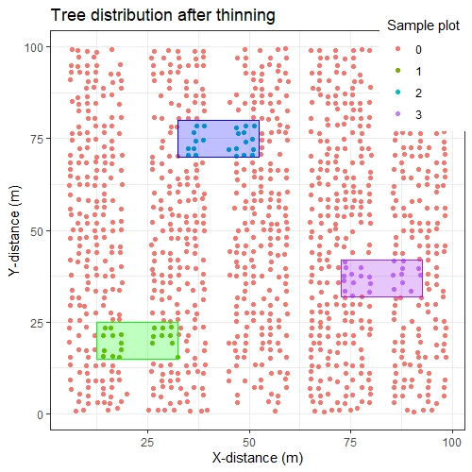
Figure 1 Location of sample plots based on sample design 3 in a post-thinned stand. ‘0’ represents the live trees outside of the sample plots. The dots represent spatial location of lodgepole pine trees in a 55-year-old TASS simulated stand (SI=20, Planting density=2400 stems/ha).

